Title [Font Times New Roman 14 pt Bold]

First author*¹ , Second author ² , Third author³ [Times New Roman 11]
*¹Department, College, University, City, Country
²Department, College, University, City, Country
³Department, College, University, City, Country

Received 00/00/0000, Revised 00/00/0000, Accepted 00/00/0000


Copyright© 2025. The Author (s). Published by College of Agricultural Engineering Sciences, University of Baghdad. This is an open-access article distributed under the term of the Creative Commons Attribution 4.0 International License, which permits unrestricted use, distribution, and reproduction in any medium, provided the original work is properly cite.

ABSTRACT [Times New Roman 12 pt, Bold]
The abstract must be no longer than 250 words and must clearly emphasise the objective of the study. [Times New Roman 11pt]

Key words: provide 4 to 6 key words or phrases that will be useful for retrieval and indexing. The key words must be separated by semi commas and should not include acronyms. Key words should not be a virtual copy of the title. Alphabetically arrangement. [Times New Roman 11pt].

INTRODUCTION [Times New Roman 12 pt, Bold]
The Introduction section should explain: The background to the study. The aims. A summary of the existing literature. The reason why the study was necessary, and the novelty must be explained. [Times New Roman 11pt, 1.15 space]. (The reference should be sited as APA style)

MATERIALS AND METHODS [Times New Roman 12 pt, Bold]
Studied traits: [Times New Roman 11 pt, Bold]
The methods section should include: Specify the time and place of study. The design, and setting of the study. The characteristics or description of material. A clear description of all processes and methodologies employed. The type of statistical analysis used. [Times New Roman 11pt, 1.15 space]. (The reference should be sited as APA style)

RESULTS AND DISCUSSION [Times New Roman 12 pt, Bold]
The result and discussion can be written in the same section or separately. This section must show the acuity of the analysis, including a description of the findings of the work (Table 1). All figures and tables should be clear. The discussion should explore the significance of the results of the work (Figure 1). Highlight differences between the results and the previous publications by other researchers. [Times New Roman 11pt, 1.15 space]. (The reference should be sited as APA style)

Table 1. xxxxxxxxxxxxx . [Times New Roman 11pt].
ABCD | AABBCCDD
ABCD | AAA | BBB | CCC | DDD
aaaaa (mg l⁻¹) | 000.00 | 000.00 | 000.00 | -
bbbbb (mg l⁻¹) | 000.00 | 000.00 | 000.00 | -

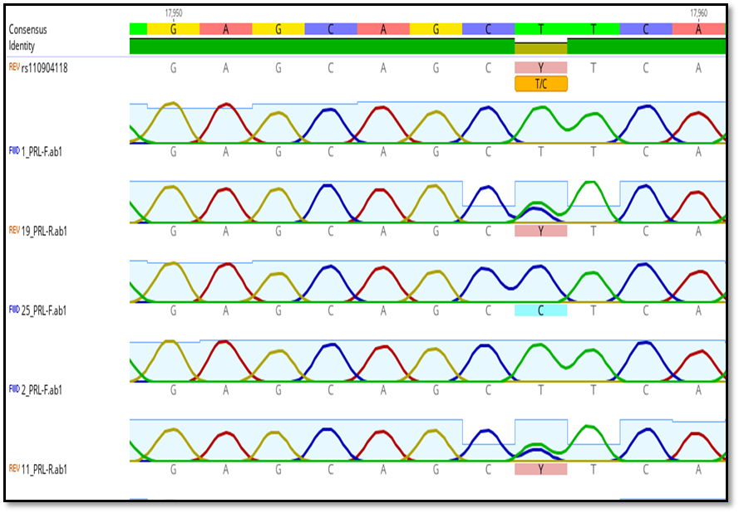

Figure 1. xxxxxxxx [Times New Roman 11pt].

CONCLUSION [Times New Roman 12 pt, Bold]
Conclusions should answer the research objectives of the research and should be clearly explained. [Times New Roman 11 pt, 1.15 space]

ACKNOWLEDGEMENT [Times New Roman 12 pt, Bold]

CONFLICT OF INTEREST
- The authors declare that they have no conflicts of interest.

AUTHOR/S DECLARATION
- We confirm that all Figures and Tables in the manuscript are original to us. Additionally, any Figures and images that do not belong to us have been incorporated with the required permissions for re-publication, which are included with the manuscript.
- Author/s signature on Ethical Approval Statement.
- Ethical Clearance and Animal welfare
- Funds:

AUTHOR’S CONTRIBUTION STATEMENT

REFERENCES [Times New Roman 12 pt, Bold]
[Times New Roman 10 pt, 1.15 space]

العنوان [Times New Roman 14 pt, Bold]

الباحث الاول¹، الباحث الثاني² [Times New Roman 11 BOLD]

قسم اااااا، كلية اااااا، جامعة ااااا،العراق.
المستخلص
يجب ألا يتجاوز الملخص 250 كلمة ويجب أن يؤكد بوضوح على هدف الدراسة. . [Times New Roman 11pt]

الكلمات المفتاحية: قدّم من ٤ إلى ٦ كلمات أو عبارات رئيسية مفيدة للاسترجاع والفهرسة. يجب فصل الكلمات الرئيسية بفواصل، ويجب ألا تتضمن اختصارات. يجب ألا تكون الكلمات الرئيسية نسخة افتراضية من العنوان. مرتبة ابجديا. [Times New Roman 11pt]

